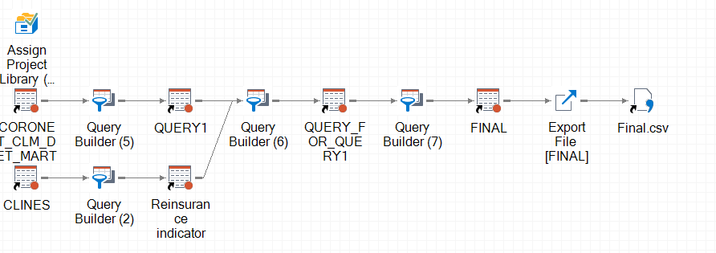
LIBNAME CLAIMS1 BASE "/project/biuk/azukbi1/data/prod_sum_3/claims/low_level_summaries" ;

